ML I PROJECT (Milestone 4)

ELECTRIC VEHICLES (EV) IN WASHINGTON STATE

OBJECTIVE

The goal of this study is to create models to understand the practices and incentives of the population of the state of Washington regarding the use of EVs and to implement the main factors involved in predicting its future trend.
Understanding how various demographic, economic, and geographic factors influence EV ownership is key to predicting future adoption patterns and informing policy-making.

This project aims to analyze and model EV adoption trends across Washington’s counties using publicly available datasets. Specifically, we seek to uncover how population size, median household income, and regional characteristics correlate with EV registration rates.

The goal of this Exploratory Data Analysis (EDA) is to understand the structure and quality of the data, identify key relationships, and highlight patterns that will later guide the development of predictive models.

DATA Overview
Table 1 shows the various sources from which relevant data was obtained pertaining to the EV Adoption study.

Table 1
Data Files

Dataset | Source | Time Period |  | Key Variables | Size/Instances | Type
Washington EV Population Data | catalog.data.gov – Electric Vehicle Population Data |  | Current year (updated quarterly) | County, Make, Model, Year, Electric Range, Vehicle Type (BEV/PHEV) | 257635 | Categorical, Numerical
WAOFM Population Estimates | catalog.data.gov – April 1 Population by State, County and City (1990–Present) |  | 1990–2025 | County, Year, Population | 409 | Numerical, Time Series
Median Household Income (NIH HDPulse Portal) | hdpulse.nimhd.nih.gov |  | 2020–2024 | County, Median Income, Demographics | 42 | Numerical
EV Price Reference | insideevs.com – Electric Car Prices in the U.S. |  | 2021-2024 | Model, MSRP | 4 files  260-600 / file | Numerical

DATA Cleaning

Data (features) from all the resources are collected and merged into one master file. Redundant features or information irrelevant to the study are eliminated.
The following changes were made:
- EV location is split into two features: ‘Latitude’, ‘Longitude’. This useful in plotting density of EVs by location within Washington.
- 2025 population data was extracted from the population resource file (Table 1) and merged with the original EV data file.
- Median Income per Family in each county is obtained from the Data Source, and added as a new feature in the master file.
- Clean Alternative Fuel Vehicle (CAFV) is the term designated by EPA for an EV that meets the requirement Electric Range of and EV Battery to qualify for state tax relief. The clean energy law requirements were adopted by Washington in 2022.

https://afdc.energy.gov/laws/6216#:~:text=Washington%20adopted%20the%20California%20vehicle%20emissions%20standards,see%20the%20Washington%20Clean%20Car%20Standards%20website.

Under the current requirement, battery range for BEV should be ≥ 200 mi, and for PHEV should be ≥ 30 mi.
- Crucial information regarding base MSRP, and Electric Range was missing from 253868 instances, equivalent to data for 587 unique values of ‘Year_Make_Model’. The data was manually collected from websites such as:
- api.marketcheck.com
- Edmunds
- audiclubna.org
- InsideEVs.com
- kbb.com
- TopElectricSUV
- ..
- ..etc.
- Tax Credit could be a major factor in more consumers adopting EVs through lowered prices ($5000 to $7500). Tax Credit, is available only for EVs manufactured in the past 5-7 years. It is a function of sales of a particular make. If the sales number exceeds a certain number set by federal government, the tax credit policy no longer applies. The policy is honored only in some states, including Washington. The sparse data could induce confidence in the results of a model. Despite the sparsity, the feature cannot be ignored. Hence its inclusion in the list of features.
Finally, only the following features are retained:

Table 2
Final Features

 | Features | Data Type
1 | County | Object
2 | Latitude | Float64
3 | Longitude | Float64
4 | Year | Float64
5 | Make | Object
6 | Model | Object
7 | Vehicle Type | Object
8 | CAFV Eligibility | Object
9 | Year_Make_Model | Object
10 | POP_2025 | Int64
11 | Median Income | Int64
12 | MSRP | Int64
13 | Dest. Charge | Int64
14 | Tax Credit | Int64
15 | Electric Range | Int64

DATA EXPLORATION & ANALYSIS

EVs by Vehicle Characteristics

Understanding data visually and in tabular form helps in deciding the appropriate modeling approach for this dataset.

Table 3 shows the basic statistical values of numeric features in the dataset.
The shaded part represents Battery Electric Vehicles (BEV), and the remaining half represents Plug-In Hybrid Electric Vehicles (PHEV).

Table 3
Descriptive Statistics for EV Data

 | BEV |  |  |  |  | PHEV
Statistic | Electric  Range  (mi) | MSRP  ($) | Year | Median  Income  ($) | Pop.  2025 | Electric  Range  (mi) | MSRP  ($k) | Year | Median  Income | Pop.  2025
Max | 492 | 420k | 2026 | 155k | 2412k | 153 | 845k | 2026 | 155k | 2412k
Min | 29 | 23k | 2000 | 66k | 3.95k | 1 | 26k | 2010 | 66k | 2.3k
Mean | 260 | 49.6k | 2022 | 133k | 1510k | 31.5 | 47.4k | 2021 | 128.5k | 136k
Median | 265 | 45.0k | 2023 | 155k | 2412k | 32 | 44k | 2022 | 127.5k | 960k
Std. Dev. | 68 | 167k | 2.8 | 24k | 953k | 14.3 | 17.7k | 3.6 | 25.4k | 980k
*mi=Miles, **$=USD, ***k=1,000

Interpretation of the values in Table 3:
- Difference between Electric Range values of BEV and PHEV is large, reflecting the fundamental technology difference.
BEV range is expanding rapidly with technological innovation, compared to PHEV range.
- Low range PHEVs ( < 10mi) represent older models at the advent of hybrid vehicles.
- Average MSRP as well as median values of MSRP for BEV & PHEV are similar, although there are some outliers with high prices for PHEV ($845k).
- The statistics for Year shows that there is a shift toward BEV production in the last 5 years.
- Demographic and geographic variables show that median income & population for BEV adopters are slightly higher than those for PHEV, suggesting that BEV is more popular in urban areas, where the median income is higher as well compared to lower income populations residing far from cities and suburbs.
- BEVs have much higher variance in electric range (std ≈ 67.7) than PHEVs (std ≈ 14.3).

Figure 1 shows box plots for features Year, BEV Range, PHEV Range, MSRP, Median Income, POP_2025. The main features with extreme outliers are MSRP ( ≥ $101,360 ), and Year ( ≤ 2008 ). Modeling using Linear Regression or using PCA algorithm can be affected by the extreme outliers. The red line within each box represents the median of each feature.

Figure 1

Box Plots for Numeric Features

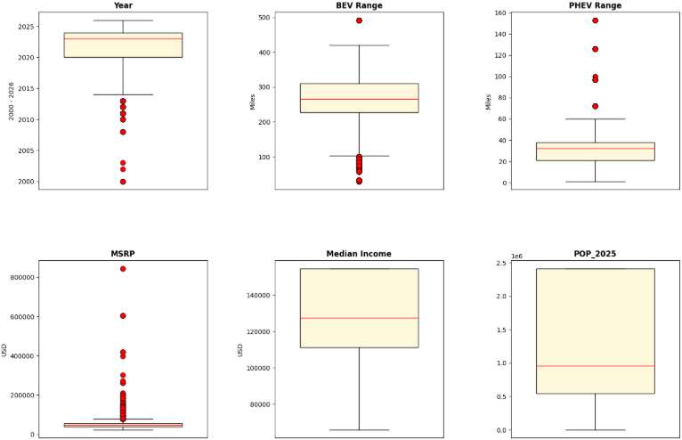

Figure 2 highlights the number of BEVs / PHEVs vs. price of vehicle. The mode for BEV is ~ 5 times as much as mode for PHEV, indicating the preference of BEV adoption as much higher as compared to that of PHEV. There are, however, extreme outliers both for BV and PHEV.

Figure 2

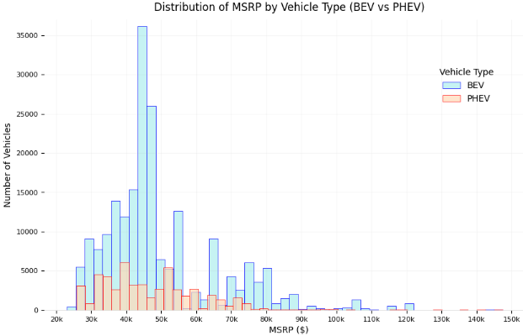

Figure 3a CAFV Eligibility for the EVs. 20% of all EVs is PHEV of which ~83% are not eligible as CAFV. Whereas only 4% of BEV are ineligible to qualify as CAFV (Figure 3b). These figures explain why BEV is the preferred vehicle for adoption in Washington.

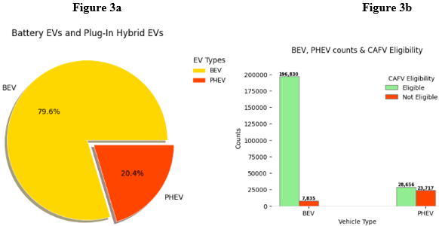

Figure 4 is the correlation matrix for numerical features. Electric Range is split into PHEV and BEV Electric Range. The matrix shows high correlation between population and median income (0.96). For Linear Regression or for PCA, only one of the features is needed.

Figure 4

Heat Map for Feature Correlation

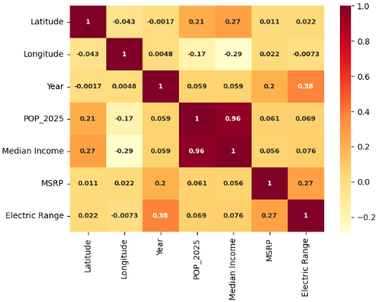

Figure 5 shows a histplot for the number of EVs grouped by Electric Range. There are 2 distinct groups in the figure. The ranges < 200mi typically belong to PHEV, and the range > 200mi belong to BEV. Electric Range for BEV appears to be roughly normal.

Figure 5

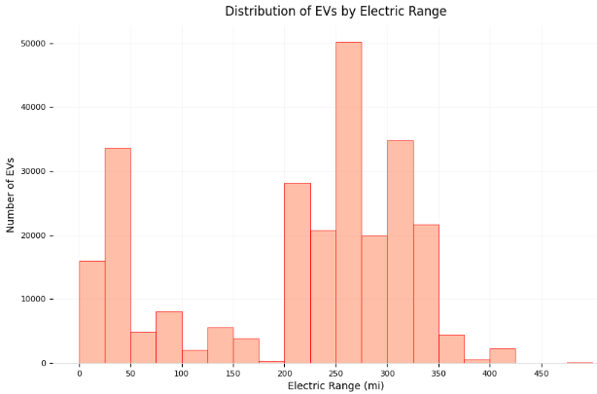

EVs by Geographic Locations

Figure 6 shows density EVs by location. The dark blue areas show higher density of EVs compared to light blue areas where EV adoptions are less in number. Clusters of EVs are in urban areas and fewer in rural areas. Counties such as King, Pierce, Snohomish, Kitsap, Mason, Thurston, Island & San Juan counties have the highest numbers of EVs, followed by Spokane and Clark counties.

Figure 6

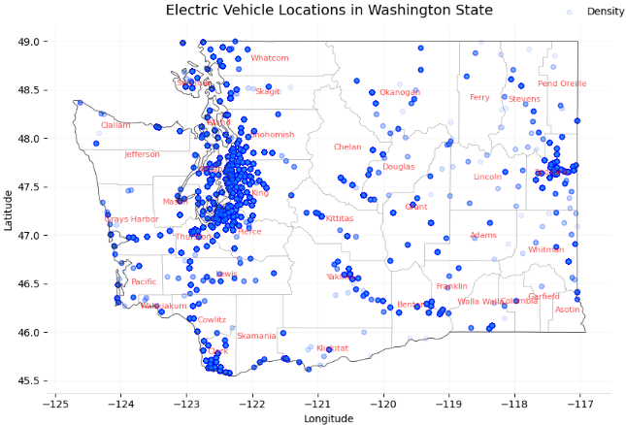

Figure 7 shows density of BEV and PHEV by color. Shades of green BEV density, and shades of yellow show PHEV density. Urban areas have more BEVs compared to rural areas that are sparsely populated.

Figure 7

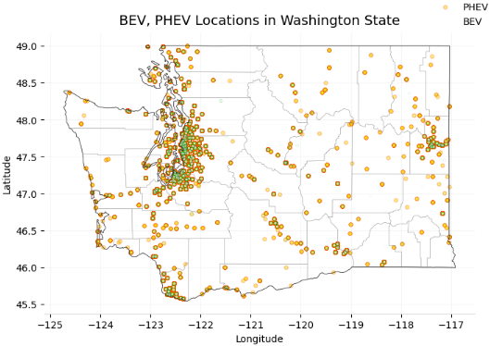

Figure 8 illustrates the EV density by median family income. Blue areas indicate high concentrations of EV, whereas the lighter shades of green show low concentration. The larger circles imply higher median family income, and the smaller circles lower income. Both higher incomes and high EV adoptions are clustered in urban areas.

Figure 8

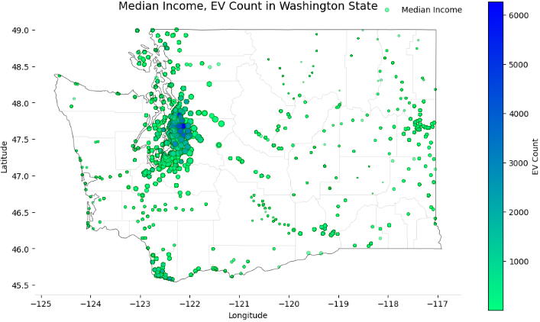

Figure 9 shows population and EV density. The circle size indicates population, and the color indicates the number of EVs. A small area of shades of blue shows the highest number of EVs in the state. Visualization in figures 6, 7, 8, and 9 aid in modeling for clusters.

Figure 9

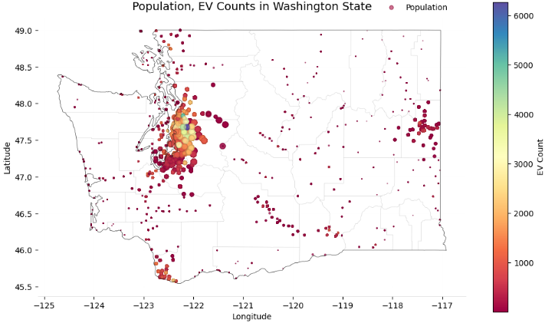

PRELUDE TO MODELING

Potential algorithms suitable for modeling:
- Features such as, Electric Range, Median Income, POP_25, and Year are numeric and continuous.
However, some strong to moderate correlations exist. Choice between Median Income and POP_25 has to be established, or a new feature combining the two has to be created.
Relationship between BEV Range vs. MSRP can be considered.

Linear regression is suitable for predictions, such as MSRP as a function of: BEV Range, Year, Median Income, Tax Credit.
Or, in predicting Electric Range from features like MSRP, Vehicle Type.

- Non-Linear algorithms such as PCA, UMAP, DBSCAN can be used to study clusters, and the EV data can be used to train Random Forest Classifier. Since, not all features are numerical or linear, Random Forest Classifier is assumed to be a good modeling choice.

RANDOM FOREST CLASSIFICATION using
PCA, UMAP, HDBSCAN

OVERVIEW

The EV dataset has 257038 instances and 15 features, with the following characteristics:

- County name, EV make, EV model, EV year, EV type (categorical)
- Electric Range (numerical)
- Tax credit (sparse numerical converted to encoded)
- CAFV Eligibility (encoded)
- Median Income by County (numerical)
- County population (numerical)
- Geographical coordinates (numerical)

The EV dataset has primarily two types of information:
- Marketing
- Geographical

- Vehicle Features: Year, Make, Electric Range, MSRP, Vehicle Type, CAFV Eligibility, ‘has_tax_credit’, ‘has_dest_charge’.
These features provide information regarding consumer preferences, vehicle & market evolution, policy effects & environment consciousness.

- Geographic Features: Latitude, Longitude, Median Income, Population.
These features describe EVs in geographic locations based on the income and the population.

Splitting the data is helpful for the following reasons:

- Features range on different scales and include extreme values:
- Prices range $30k–$150k
- Latitude/Longitude are coordinate pairs
- Population spans thousands to millions
- Make & Vehicle Type are categorical

- Sets of features represent different latent structures
- Vehicle features – technology & economic versus luxury
- Geographical features – spatial & socioeconomic patterns

- Clarity of interpretation
- UMAP for vehicle data shows clusters pertaining to marketing segment
- UMAP for geographic data shows regional adoption clusters

- Different hyperparameters for each split
- Vehicle data is wide-ranging, both in numerical & categorial, and needs strong noise reduction.
- Geo data is low dimensional; it needs smoother, lower-complexity embeddings.

Therefore, feature separation is useful for initial analysis & for ease of interpretability.

PCA
Since, the dataset is high dimensional, the features include sparse data, noise, outliers, high correlation with one another.
PCA creates new features based on the original features, and retains only those with meaningful variance & discards the remaining. Doing so stabilizes the following algorithms.
UMAP is highly sensitive to data variations. If UMAP is applied to unprocessed data, the insignificant patterns or noise could be exaggerated. PCA reduces anomalies and smooths the data, so that UMAP can reveal the true latent structures.
Dimension reduction by PCA, while preserving relevant information, improves speed & performance.

Finally, UMAP relies on distance. The ‘curse of dimensionality’ is mitigated by PCA, which compresses features into manageable space.

UMAP
While PCA reduces dimensions and compresses features, UMAP exaggerates and reveals patterns that are non-linear.
Examples: BEVs are predominantly long range compared to PHEV
Spatial adoption patterns are irregular
Income, incentives & EV adoption are non-linear.

UMAP can maintain both local clusters as well as large scale separation between clusters (HDBSCAN).
UMAP is ideal for a combination of numerical & categorical encodings.
Examples: One-hot encoded EV makes
Spatial coordinates
Non-linear relationships (Year & Range).

HDBSCAN
(Hierarchical Density-Based Spatial Clustering of Applications with Noise)

This clustering algorithm
- Groups points based on density, and not simply distance
- Determines the number of clusters automatically
- identifies noise/outliers (cluster = -1)
- Handles clusters of various shapes
- Works well with UMAP for non-linear embeddings

HDBSCAN is particularly useful for the EV data, since it is density-based, it can identify clusters within clusters and prioritize stable clusters. So, after UMAP identifies shapes, HDBSCAN identifies clusters within the shapes.

RANDOM FOREST CLASSIFIER

Random Forest is supervised learning method. While HDBSCAN is unsupervised, it assigns each data point a cluster_id. Each of these clusters becomes a class in RF multi class classification.
Since the goal with the present data is market grouping, segmentation & pattern discovery, HDBSCAN becomes useful & necessary. RF is then used to predict the clusters the new data should belong to.

HYPOTHESIS

Based on EDA, the following hypothesis can be tested:
- Geography, and socio-economic factors dominate EV adoptions.
- Incentive trends, and infrastructure drives up EV adoptions.
- BEVs have higher adoption rate due to price range from moderate to high, and very high electric range.

ASSUMPTIONS

PCA

- Data should be numerical; categorical data is encoded.
- Structuring and variance lies in linear combinations of features.
- No extreme outliers, since PCA is sensitive to outliers, which inflate variance.

UMAP (Has geometrical assumptions, unlike PCA which has statistical assumptions.)

- Local structure is more important than global structure. The nearest neighbors represent the true manifold shape. Features are scaled to avoid distorted neighbor graphs.
- The data is assumed to lie on a low-dimensional manifold embedded in the original space.
- Density separations are crucial for UMAP clustering.

HDBSCAN

- Each cluster forms a ‘mountain peak’ of density
- Noise / outliers are low-density points.
- Clusters are not bound by any particular size or shape.
- Clusters depend on the UMAP outputs, which in turn depends on the PCA outputs.
- Optimum cluster-size is chosen; between small meaningless clusters to large noisy clusters.
- HDBSCAN clusters are valid, along with each label for each cluster. This is the most important assumption before applying random forest classifier.
- Every cluster large or small are treated equally while learning.

RANDOM FOREST CLASSIFIER

- Cluster labels represent meaningful, stable classes.
- Features used for clustering are the same as those used for classifying.
- Enough samples per class. Tiny clusters hurt the model predictions.

CHARTS & ANALYSIS

Preliminary Cluster Analysis
- Market Segmentation – Based on Vehicle Characteristics

This study is to observe the cluster formation independent of geographical coordinates or socio-economic factors. The features include:

Make, Vehicle Type, CAFV Eligibility, Year, Electric Range, MSRP, has_tax_credit, has_dest_charge.

Categorical features like ‘Make’, ‘Vehicle Type’, ‘CAFV Eligibility’, are encoded using OneHotEncoder. Numeric features are standardized using StandardScaler, to equalize the contribution scale from each field. This is implemented because PCA, UMAP and HDBSCAN are distance based, and not scaling the features may cause disproportionate dominance by some features over others.

To reduce dimensionality before applying UMAP, PCA is applied. The number of PCA components was selected dynamically using:
$$\text{n_components}=min⁡(30,\text{ number of input features}-1)$$
The dynamic selection of components means that PCA cannot have more components than the number of features.
The role of PCA is to reduce > 100 scaled features to ~ 30 components, removes noise and correlated features and prepares the data for UMAP.

UMAP learns the latent structure, and projects the data into a 5-dimensional manifold. It preserves the ‘neighborhood’ of EVs with similar features. UMAP separates dense groups, compresses noisy regions, defines natural cluster boundaries.

HDBSCAN finds the clusters with similar characteristics based on geometric shapes generated by UMAP, and labels them. Low confidence points are assigned to a cluster labeled -1.
UMAP coordinates are assigned to each cluster.

Figure 1 shows the clusters in this UMAP space. Each circle is around its centroid (the average position of EVs within the circle). Large circles are the most common types of EV segments, and the small circles are clusters of niche EV types.
The central UMAP space has higher density of clusters compared to the periphery. The central centroids may share common vehicle characteristics like Price, Battery Range, Vehicle Type etc..
Whereas the peripheral smaller circles may have uncommon vehicle types.
The plot may provide marketing insights into mainstream EVs with moderate specs, as well as rare, high-end or older models.

Figure 1

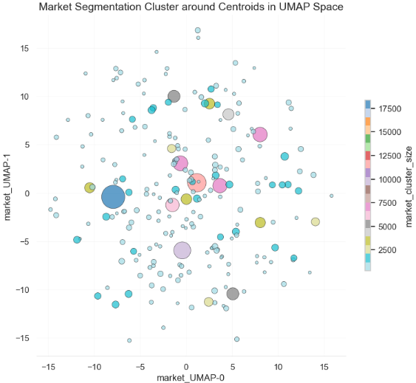

Figure 2 shows the clusters mapped back to actual vehicle features, Range vs. MSRP of EVs manufactured (and adopted) over 14 years. The darker clusters are older vehicles. They are also small indicating low adoption rate prior to 2015. Clusters for Electric Range < 100mi belong to PHEV, whereas the higher Range clusters imply BEV. A cluster of clusters of various shades of green >200mi indicates more BEVs of high Range performance with moderate pricing. Small light green clusters indicate, new model with high performance and expensive trims.
Clusters in the lower left corner of the plot belong mostly to PHEVs with low Battery Range and low pricing. However, there are new models, possibly luxury PHEVs, where performance is not the objective (cluster in the lower right corner).
The figure also shows that the marketplace is dominated by BEVs.

Figure 2

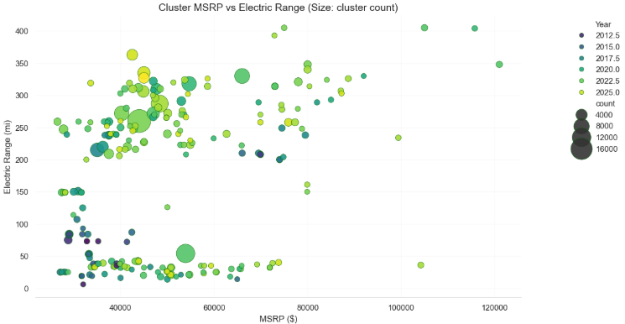

- Geographic Segmentation – Based on EV adoptions at Geographics locations

This study is to observe the cluster formation depending on geographical coordinates or socio-economic factors. The features include:

Latitude, Longitude, Median Income, POP_2025.

All features in this case are numeric and do not include any vehicle description.

Figure 3 UMAP’s embedding of high dimensional data into 2D. Separations in 5D when projected on to 2D may appear to overlap. However, in the present graph, the original features, geographical locations of EVs and local earnings and populations may have commonalities. UMAPs may not guarantee perfect separation between clusters.
Overlapping clusters reflect the true proximity in the features space here.
Big circles represent dense clusters, with large numbers of similar geo-economic structures. The small circles represent everything outside of the most common features. Each circle may have some feature more prominent that others, and in smaller numbers (low density).

Figure 3

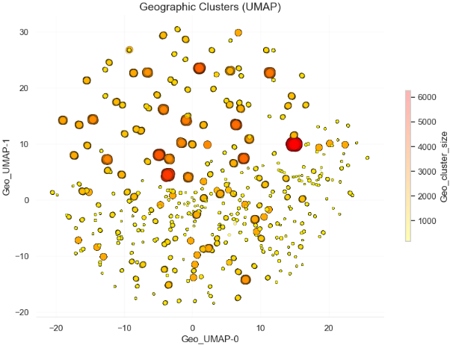

Figure 4 puts the above plot in context of the true features. The darkest and the biggest clusters match graphs from the EDA section. Geo-socio-economic circumstances are major determinant of the high EV adoption rate. Small yellow circles indicate smaller numbers of EV adoption along with economic circumstances unlike the those of the large dark circles.

Figure 4

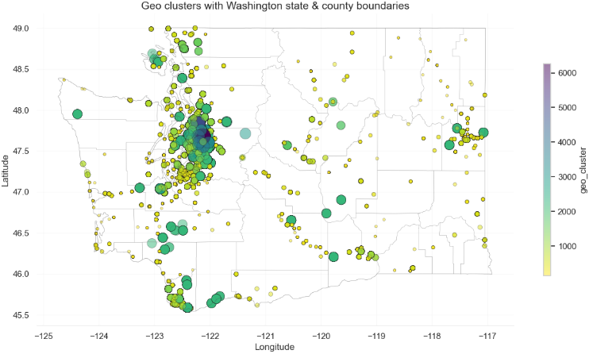

In (a), HDBSCAN generated 226 clusters. In (b) HDBSCAN generated 274 clusters. The business goals and policy goals are ultimately related to geo-economy. So, all features are incorporated into the “Geographic Segment”.

Thus, we retain 274 geographic clusters in the final segmentation for modeling. They represent the most granular as well as meaningful structures for location based EV analysis.
Figure 5 shows the frequency of each of the 274 clusters.

Figure 5

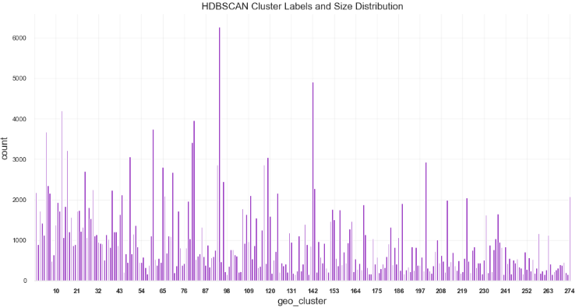

RANDOM FOREST CLASSIFICATION MODEL

HDBSCAN discovered and labeled clusters from the EV data. RF model learns to predict the appropriate cluster for a new EV without re-running the HDBSCAN.

Using the features used for HDBSCAN for clustering, a supervised dataset is created.
Preprocessing is performed using OneHotEncoder on categorical features &
StandardScaler() on numerical features.

Random Forest Classifier is defined and trained as:

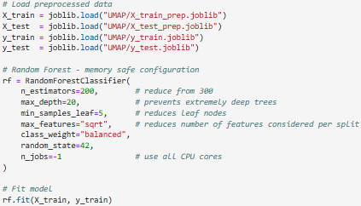

For Cross Validation, the training data is split into 5-folds, and each fold tested separately.
The results are in the following 5 tables (Tables, 1(a), 1(b), 1(c), 1(d), 1(e))

Cross Validation Results of Random Forest Classifier on EV Data

Table 1
1(a)

 | Cross Validation: Fold 1
 | Precision | Recall | F1-Score | Support
Accuracy |  |  | 0.88 | 38556
Macro Avg | 0.81 | 0.83 | 0.81 | 38556
Weighted Avg | 0.89 | 0.88 | 0.87 | 38556

1(b)

 | Cross Validation: Fold 2
 | Precision | Recall | F1-Score | Support
Accuracy |  |  | 0.87 | 38556
Macro Avg | 0.81 | 0.83 | 0.81 | 38556
Weighted Avg | 0.89 | 0.87 | 0.87 | 38556

1(c)

 | Cross Validation: Fold 3
 | Precision | Recall | F1-Score | Support
Accuracy |  |  | 0.87 | 38556
Macro Avg | 0.80 | 0.82 | 0.80 | 38556
Weighted Avg | 0.89 | 0.87 | 0.87 | 38556

1(d)

 | Cross Validation: Fold 4
 | Precision | Recall | F1-Score | Support
Accuracy |  |  | 0.87 | 38556
Macro Avg | 0.80 | 0.83 | 0.80 | 38556
Weighted Avg | 0.88 | 0.87 | 0.87 | 38556

1(e)

 | Cross Validation: Fold 5
 | Precision | Recall | F1-Score | Support
Accuracy |  |  | 0.88 | 38556
Macro Avg | 0.81 | 0.83 | 0.81 | 38556
Weighted Avg | 0.89 | 0.88 | 0.88 | 38556

Test Set Results of Random Forest Classifier on EV Data

Table 2

 | Test Set
 | Precision | Recall | F1-Score | Support
Accuracy |  |  | 0.88 | 64260
Macro Avg | 0.82 | 0.84 | 0.82 | 64260
Weighted Avg | 0.90 | 0.88 | 0.88 | 64260

The average Accuracy from Cross Validation of the RF Classifier is : 0.8738; Standard Deviation between the Accuracy values is 0.0027
The Accuracy from Testing of the RF Classifier is : 0.8845

Explanation of the test results:

- StratifiedKFold uses 80% of training data and 20% of training data for cross validation (CV). Whereas the final model is trained on the entire training set before testing, hence the higher score (by 1.07%) for testing data.
- Extremely low standard deviation for CV implies that the model is
Stable,
Not sensitive to data shuffling
Not Over/Under-fitting

The following were the observations and deductions of the process.
Accuracy vs. f1
- The overall accuracy was ~87% on the test set. This is due to larger clusters (more data) dominating in setting the model parameters. However,, a number of smaller clusters with significantly different characteristics from the large clusters end up being identified incorrectly.
- f1 = 80% for macro average compared to Weighted average of 87%. This could be because the small clusters perform differently(unreliably) compared to larger clusters, due to imbalance in the data.
Therefore, the model is reliable for large clusters, which likely represent the majority of EV markets, but less reliable for rare EVs, or rare customer preferences.

Figure 6 shows a plot of Cluster Accuracy vs. cluster size.
Small clusters show a wide range of accuracy. This is because with few samples in a cluster (< 200), the prediction for that cluster becomes difficult. Thus, the accuracy data looks noisy.

For larger clusters (> 200), the accuracy improves significantly with increase in cluster size. This is because, large clusters represent dominant features and most common features found in EV instances, which are easier to predict and result in less error.

Figure 6

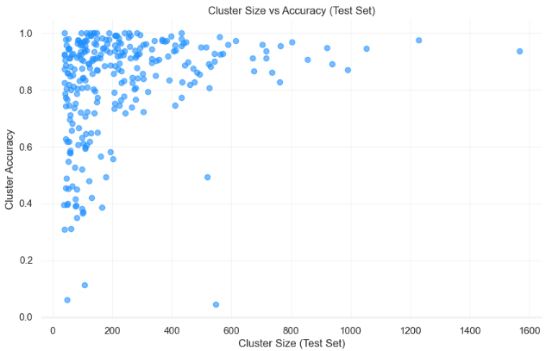

Feature Importance (Figure 7):
Random forest ranks features by how much they reduce misclassification across trees in the forest. A feature is of high importance, if splitting it produces homogeneous nodes. A feature of importance appears around the top (root) of the tree.

In the present EV data, Latitude, Longitude, Median Income and Population combined represent > 90% of all feature-importances. This is because EV adoptions are predominantly based on geo-economic factors, rather than any vehicle characteristics.

Figure 7

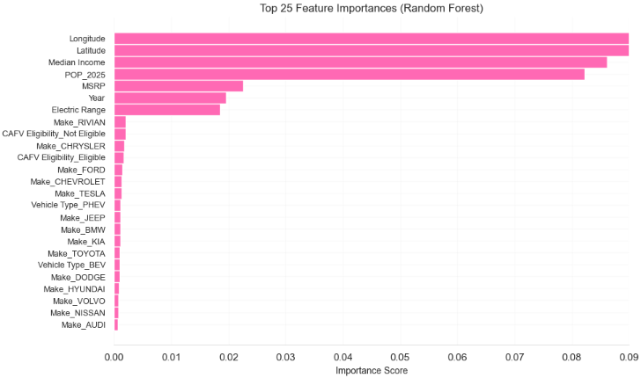

Figure 8 compares actual cluster sizes with predicted cluster sizes. While predictions are very close, the true slope is 0.93 (less than the ideal slope of 1). The abundance of smaller & similar sized clusters, make it prone to misclassification, as is illustrated in Figure 6. The regression lines passing through this cluster of clusters appears indistinguishable.
However, there are few large clusters. While their largeness provides a new instance with the advantage of being classified correctly, the size predicted is slightly less than the actual cluster size. This is due to the inherent nature of the HDBSCAN. Large clusters have irregular shapes, and densities. Central points are easier to classify, whereas points near edges are not. This can affect the prediction. Therefore, predicted sizes are slightly smaller than the actual sizes, reducing the true slope to ≲ 1.0 (ideal slope).

Figure 8

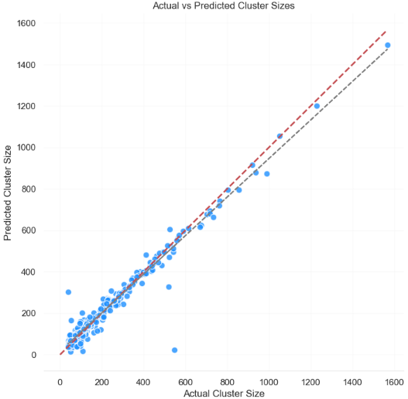

Small Clusters

Figure 9 visualizes errors made by RF classifier when predicting HDBSCAN cluster labels. The points represent samples embedded into two dimensions using UMAP, while color indicates classification accuracy.
Observations:
- Classification errors (red) arise in multiple density regions.
- Underlying cluster boundaries may be inherently ambiguous.
- In the outer areas of the embedding, where points are more isolated, misclassification is minimal, since the clusters a well separated. They could represent unique characteristics like: high MSRP vehicles, rural low-income areas, very low or very high Electric Range EVs.

Misclassifications reflect the complexity of the task.

Figure 9

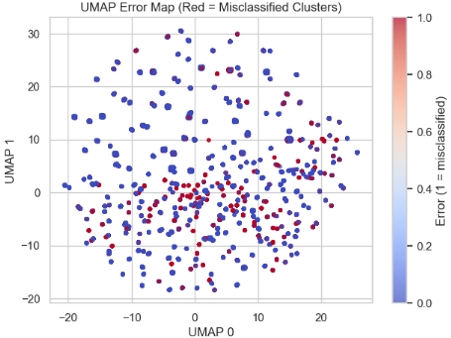

LINEAR REGRESSION

For Cross Validation, the training data is split into 5-folds, and each fold tested separately.
The results are in the following 5 tables (Tables, 1(a), 1(b), 1(c), 1(d), 1(e))

Cross Validation Results of Linear Regression on EV Data

Table 1
1(a)

 | Cross Validation: Fold 1
Metric | R2 Score | RMSE | MAE | MSE | Support
Value | 0.8431 | 48.1122 | 48.1122 | 36.3249 | 41,126

1(b)

 | Cross Validation: Fold 2
Metric | R2 Score | RMSE | MAE | MSE | Support
Value | 0.8514 | 46.9901 | 35.9102 | 36.3249 | 41,126

1(c)

 | Cross Validation: Fold 3
Metric | R2 Score | RMSE | MAE | MSE | Support
Value | 0.8479 | 47.5623 | 48.1122 | 36.2951 | 41,126

1(d)

 | Cross Validation: Fold 4
Metric | R2 Score | RMSE | MAE | MSE | Support
Value | 0.8445 | 48.0348 | 48.1122 | 36.5902 | 41,126

1(e)

 | Cross Validation: Fold 5
Metric | R2 Score | RMSE | MAE | MSE | Support
Value | 0.8496 | 47.2259 | 47.2259 | 36.1088 | 41,126

Test Set Results of Linear Regression on EV Data

Table 2
Metric | R2 Score | RMSE | MAE | MSE
Mean | 0.8473 | 47.5851 | 36.2458 | 36.1088
STD Dev | 0.0032 | 0.4550 | 0.2572 | 29.0638

INTERPRETATION OF LINEAR REGRESSION RESULTS
The average R² Score from Cross Validation of the Linear Regression model is 0.8473, and the Standard Deviation between the R² values is 0.0032.
The R² Score from Testing is 0.8467.
These values are extremely close to one another, indicating that the model is stable, not sensitive to data shuffling, and its not over/under fitting
The RMSE, MAE values follow the same pattern, with only small fluctuations across folds.
This consistency shows that the model learns linear patterns in the dataset reliably, regardless of how the data is split.
Cross Validation uses 80% of the training data and 20% of the training data for validation.
The final evaluation, however, uses a model trained on the entire training set before testing on the held-out test set.
This explains why the Test R² Score is nearly identical to the CV average.
Unlike highly flexible non linear models, linear regression tends to generalize smoothly when strong linear relationships exist in the features.

Observations and Deductions of the Process
R² Score vs. Prediction Error (RMSE / MAE)
The overall R² of around 0.85 on the test set reflects a strong linear relationship between the predictors and the target variable.
However, RMSE values of 47–48 and MAE values of around 36 indicate that prediction errors vary depending on the type of EV instance or county being predicted.
Larger or more typical data group, such as counties with stable economic profiles or EV types with consistent characteristics, are easier to predict.
Smaller or more unusual groups introduce error, since extreme values ( rare vehicles, unusual income populations, or high variance counties) contribute to larger results.
Therefore, the model performs reliably for the majority of cases but is less reliable for rare cases or extreme outliers.
Similar to the observations in the clustering model, predictable large groups dominate the model’s behavior, while smaller groups produce more dispersed error patterns.
The model’s linear nature also means that nonlinear relationships,such as interactions between incentives, geography, and EV type, cannot be fully captured.
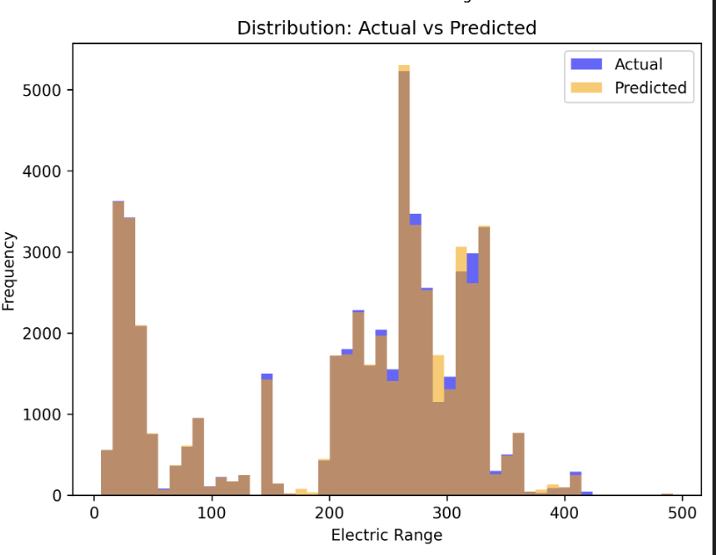
Accuracy vs. Error Patterns
The relatively high R² Score is driven by the strong influence of population, income, and EV characteristics on adoption behavior.
These variables exhibit linear tendencies in aggregate, leading to high explained variance.
Meanwhile, the error metrics (RMSE/MAE) indicate that:
- Predictions for dense, urban counties ( King, Snohomish, Pierce) are more accurate.
- Predictions for rural or low-sample counties show larger deviations.
This behavior is typical in socioeconomic data, where concentration effects and regional differences play significant roles.
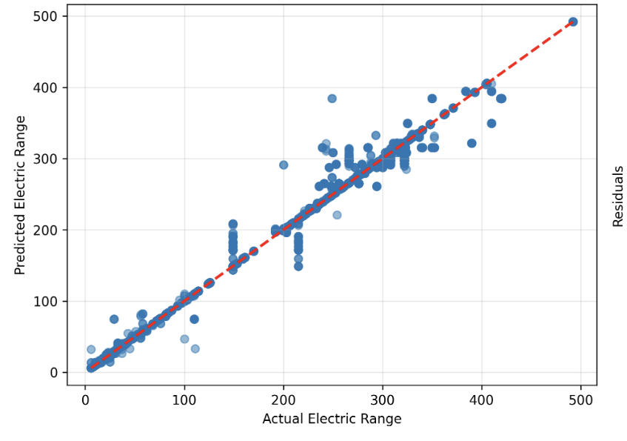
Cluster Size Analogy (Regression Context)
Although linear regression does not use clusters, the error distribution behaves similarly to the cluster-size effect observed in the Random Forest model:
- Small counties or rare EV types means higher error, more noise.
- Large counties or common EV types means lower error, more stability.
This is because the regression model learns best from dense, consistent patterns.
Sparse or unique cases offer insufficient structure for precise prediction.

Summary Interpretation
From the Cross Validation and Test results, the following conclusions were drawn:
- The Linear Regression model is highly stable, with minimal variation across folds.
- The model explains approximately 85% of the variance in the target variable, indicating strong linear relationships.
- Prediction error is moderate but reasonable for real-world EV data.
- The model is reliable for the majority of EV cases, especially those that follow general economic and demographic patterns.
- The model struggles slightly with rare or extreme cases but maintains overall generalizability.
Thus, linear regression is shown to be a strong baseline model for understanding how socioeconomic and geographic variables relate to EV adoption trends across Washington State.

CONCLUSION

This was a study on unsupervised cluster structure of EV markets.

With PCA, UMAP, and HDBSCAN, the groundwork was established for modeling using Random Forest (RF) Classifier.
The 274 clusters identified by HDBSCAN were used to train the RF classifier.
Random Forest classifier evaluated how predictable/consistent those clusters are from the input features.

RF accuracy has a high value (~0.88). This suggests that the clusters discovered by HDBSCAN are learnable. The geo-socio-economic features along with EV characteristics, are largely able to explain cluster-membership.

However, misclassification is present. The small error clusters are spread across the embedding. This implies that HDBSCAN boundaries are fuzzy, especially in transitional geographic/market regions. This also, highlights the fact that real-world market behavior is not perfectly separable.

Thus, assumptions are validated for the most part, the EV market pattern contains natural overlap that produces some misclassification.

Initial hypothesis revisited:
- Geography, and socio-economic factors dominate EV adoptions.
RF feature importance ranks geography as the main feature, followed by income, population, MSRP, Year, Electric Range …

Feature | Importance
Longitude | 0.375274
Latitude | 0.369585
Median Income | 0.084978
POP_2025 | 0.082880
MSRP | 0.022725
Year | 0.019633
Electric Range | 0.018246

Geographic and socioeconomic features play a dominant role.

- Incentive trends, and infrastructure drives up EV adoptions.
Since data regarding Tax Credit is only available for the recent 5 years, and not complete. This hypothesis could not be supported by the data at hand.
However, a boost of sales of BEV in the recent years among medium income groups do imply the influence of tax credit. And as evidenced by HDBSCAN, the clusters around urban areas could indicate robust charging infrastructure.

- BEVs have higher adoption rate due to price range from moderate to high, and very high electric range.
Clustering shows BEV-dense regions (Figure 4) tend to be:
- Moderate to high income areas
- Regions of high population density
- Urban markets

Practical Implications
- Market Segmentation Insight
The study is useful for:
- Policymakers to identify underserved areas.
- Policymakers to determine appropriate means for EV infrastructure.
- Auto manufactures to understand the market likes and dislikes of consumers.

- Predictive Understanding
By entering various feature values, a cluster label can be obtained. This helps in understanding the EV market characteristics and location for future.

